

**Project Proposal by Hectic Robos**

**CSE 299**

**Spring 2023**

**Section: 17**

**Submitted to:**

**Ms. Tanzilah Noor Shabnam**

**Department of Electrical & Computer Engineering**

**Team Members:**

1. **Siddhartha Sankar Saha (2011567042)**
2. **Taneem Ahmed (2013102042)**
3. **Mahbub Morshed Rifat (2011415042)**

**Date of Submission: 26/02/2023**

**Abstract**

Our project name is 'Sastho Seba.' Our primary target is to build software that will be helpful to patients. In our country, it is a hassle for people regarding treatment. So this software will help them with better treatment. With this software, we want to centralize the treatment system. Patients will have unique IDs and can take treatment from any hospital or clinic in the country. The benefit will be that the patient will have a disease history in his or her id. That will help the doctors to treat the patient accordingly. Also, one hospital does not accept test reports from other hospitals. It is a hassle and costly for the patient. So, this type of business will not happen if the government interferes with this software. So we will try to make the software efficient and on time.

**Table of Contents:**

|  |  |  |
| --- | --- | --- |
| 1 | Introductions | 3 |
| 2 | Literature Review | 4 |
| 3 | Motivation | 5 |
| 4 | Aim | 5 |
| 5 | Application of the project in real life | 5 |
| 6 | Tools | 6 |
| 7 | Tentative schematic diagram | 6-7 |
| 8 | Timeline | 8 |
| 9 | Project Cost | 9 |
| 10 | Conclusion | 9 |
| 11 | Contribution | 9-10 |
| 12 | Reference | 10-11 |

**Introduction**

'Sastho Seba' will be the project of humanity. In our country, people mostly do not get proper treatment. It is not because we do not have good doctors but because the treatment system is corrupted. All the hospitals and diagnostic centers are focusing on making money. The treatment quality is inferior. So, many people are going to our neighboring country for treatment. To stop this, we present this software. It will be the software where every people will have a unique ID, and they can choose any doctor from any hospital in Bangladesh. The benefit is that the patient will have all history of their diseases because every hospital has to update the treatment data. So, it will be centralized, and every hospital has to accept the test result from anywhere. Also, the Government can monitor any hospital easily because the patient's treatment history is there. If we want to connect all the hospitals of Bangladesh, it will be a vast project that we cannot complete in a limited time. Our vision is at least to centralize Faridpur city's all hospitals and diagnostic centers.

**Literature review:**

The existing project on the HMS (Hospital Management System) is mainly on the management of a hospital that connects patients, doctors, and admin of the hospitals depending on their needs. These projects have some specializations like appointments, personal details of patients and doctors, update data, lab reports generator, payment gateway, and the history of patients and appointments. We find the same types of options on all the web pages.

The projects mainly maintain the internal system of a hospital. They have an appointment system to take any consultation time for patients to avoid mismanagement. The admin has the utmost power to input the details of both patients and doctors and they can supervise the ultimate hospital management system. The pathologies update the test reports according to the patients. Doctors get information from the appointed patients and their histories. My reviewed projects are mostly designed like this and they work according to the description. They have mostly three modules that are admin, the user (patients), and the doctor module.

Getting some ideas from this project our projects had some unique works of technique. Being managing a system inside a hospital, we decide to manage the whole medical system around the country. Our objective is to manage the whole doctors, patients, and hospitals in the country. The people are registered as patients using their NID or unique id as they use to get other facilities from the country. Their whole records are preserved in the central database. Every hospital, freelancing doctor, and diagnostic center updates their test reports and much other info as the patients get no hassle to test again and again. Suppose he did his x-rays from a city like Faridpur he wants to consult in Dhaka in a week or interval of a short time he won’t need to test again as he has an x-rays report in the system and it will also work as a history of that patients. In a country like Bangladesh is tuff to communicate with some patients as they had no idea about the reports and their diseases.

**Motivation**

In Bangladesh, every people struggle when it comes to getting treatment. They are mostly poor and have to lose everything for the treatment process. So, they choose our neighboring country for better treatment. In our country, most people believe they do not get the proper treatment here. It is a significant failure for our developing country. If we can centralize the treatment, it will be a massive benefit for the people of our country. On the other hand, the people who make this great profession a business will be marked out. So, our primary motivation is to develop a software system to help people get treatment.

**Aim**

Our main goal is to fulfill a hospital management system that will not only be bounded in a single hospital. We will build a web that will connect all hospitals in BD. The patient will have a unique id, and this will connect the patient through all hospitals. The history of the patients will be pushed through the hospitals or doctors. It will make the medical system centralized and less corrupted. The treatment will be more efficient for the patients. The patient will be more benefited because life is more important than anything.

**Application of the project in real life**

The project can be used in the health sector. This project will be helpful for the people of Bangladesh. It will betterment the treatment for any patient. 'Sastho Seba' will help people find the right doctor in any hospital in Bangladesh. This software will update all patient records by the hospitals or clinics. Also, it will centralize the medical sector and will control by the health ministry. That will reduce corruption in the hospitals, and people's hassle will reduce than before.

**Tools**

 For the frontend part, we will use React.js, a JavaScript library for building user interfaces. For the Backend part, we will use Express.js, which is used as a backend in specific popular stacks, such as MERN (a Node.js framework). For database-related works, we will use Xampp Sql. Besides, we will use Postman, an API platform for building and using APIs.

**ER Diagram**

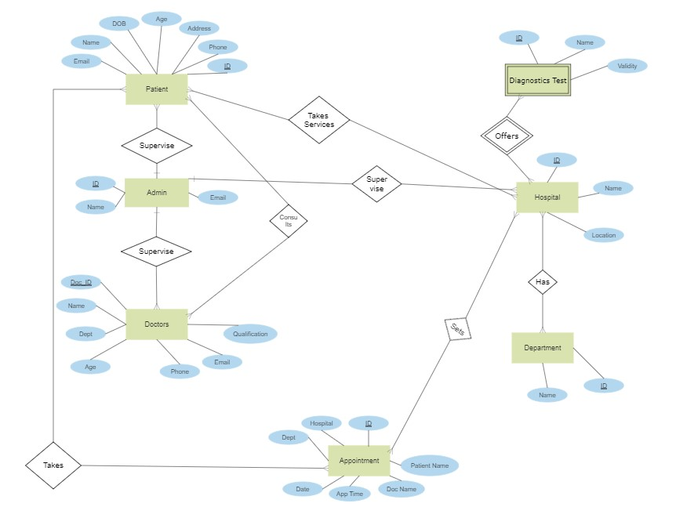

**Use-Case Diagram**

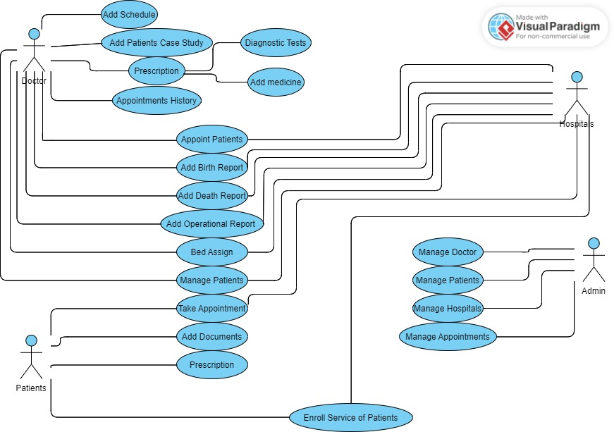

**Timeline**

|  |  |  |  |  |  |  |
| --- | --- | --- | --- | --- | --- | --- |
| WORKS | WEEK 1 | WEEK 2 | WEEK 3 | WEEK 4 | WEEK 5 | WEEK 6 |
| Work with the authentication part and built the frontend accordingly. | ------------ |  |  |  |  |  |
| Built the patient character and its frontend features. |  | ----------- |  |  |  |  |
| Create the doctor’s portal and linked the assessments. |  |  | ----------- |  |  |  |
| Work with the backend part and create API calls. |  |  |  | ------------- |  |  |
| Work with the database and deal with the problems. |  |  |  |  | ------------- |  |
| Test and validate data of the project to check if its working properly |  |  |  |  |  | ------------- |

**Projected Cost**

‘Sasto Seba’ is a software project. So, there will be no hardware cost. However, if it is successfully launched, it will be costly to maintain the software, and many servers will need to record the people's data.

**Conclusion**

‘Sasto Seba’ software will be a betterment for the people of Bangladesh. People have to face hassles for treatment. Even after that, they do not get the proper treatment. All the hospitals are making money but need to give the appropriate treatments. So, for the future of our country, it is mandatory to have a centralized treatment system. It will reduce corruption, and the patients will get proper treatment. After all, the doctor's profession is to serve the people, not do business. ‘Sasto Seba’ software will serve humanity.

**Contribution**

**Siddhartha Sankar Saha:**

* Project Idea
* Abstract
* Introduction
* Motivation
* Aim
* Application of the project in real life
* Project Cost
* Conclusion

**Taneem Ahmed:**

* Develop the idea
* Added features
* Select software for the project
* ER diagram
* Project Timeline

**Mahbub Morshed Rifat:**

* Develop the idea
* Added features
* Existing software review and collect data
* Class diagram
* References
* Ready the ppt slide

**References**

A. Kumar, “Hospital Management System in PHP,Download Hospital Management System Project on PHP,” *PHPGurukul*, 08-Nov-2022. [Online]. Available:

https://phpgurukul.com/hospital-management-system-in-php/. [Accessed: 26-Feb-2023].

G. Behara, “Hospital Management System a project report submitted in partial fulfillment of the requirements for the award of the,” *Academia.edu*, 24-May-2014. [Online]. Available: https://www.academia.edu/7149341/HOSPITAL_MANAGEMENT_SYSTEM_A_PROJECT_REPORT_Submitted_in_Partial_Fulfillment_of_the_requirements_for_the_Award_of_the. [Accessed: 26-Feb-2023].

Himani Chopra Follow HR Executive, “Hospital Management System Project,” *Share and Discover Knowledge on SlideShare*. [Online]. Available: https://www.slideshare.net/HimaniChopra/hospital-management-system-project. [Accessed: 26-Feb-2023].

“Hospital Management System,” */NAAC/CRITERIA1/samples-of-projectwork_fieldwork/computer_science/software_engineering/*. [Online]. Available: https://mscw.ac.in/naac/criteria1/samples-of-projectwork_fieldwork/computer_science/software_Engineering/. [Accessed: 26-Feb-2023].